C Y Foundation Group Limited

Stock code: 1182
Circular issue date: 26-Feb-10
Property valuation

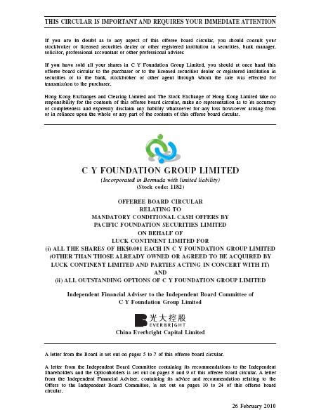

Ching Hing (Holdings) Limited

Stock code: 692
Circular issue date: 01-Mar-10
Mine valuation / technical report

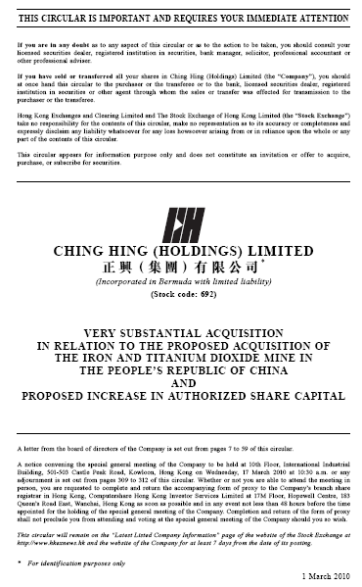

Winteam Pharmaceutical Group Limited

Stock code: 570
Circular issue date: 11-Mar-10
Property Valuation

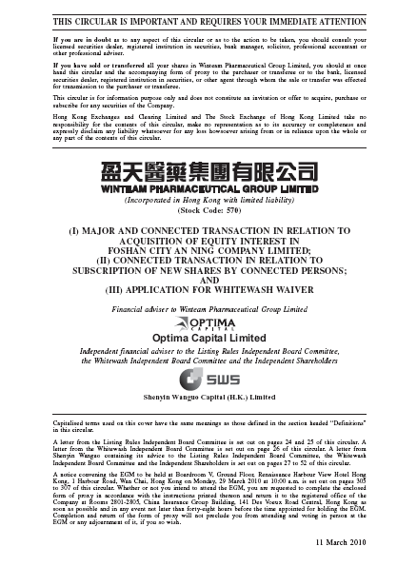

Shaanxi Northwest New Technology Industry Co. Ltd.

Stock code: 8258
Circular issue date: 15-Mar-10
Property Valuation

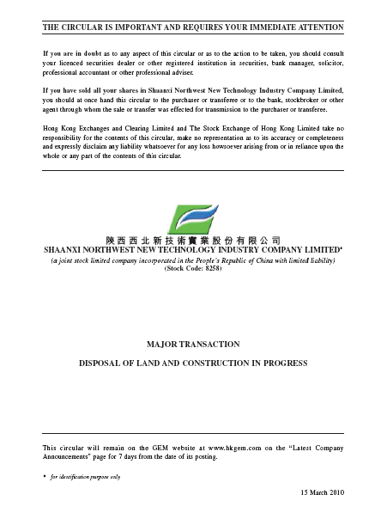

Hong Kong Resources Holdings Co Ltd

Stock code: 2882
Circular issue date: 1-Apr-10
Property Valuation

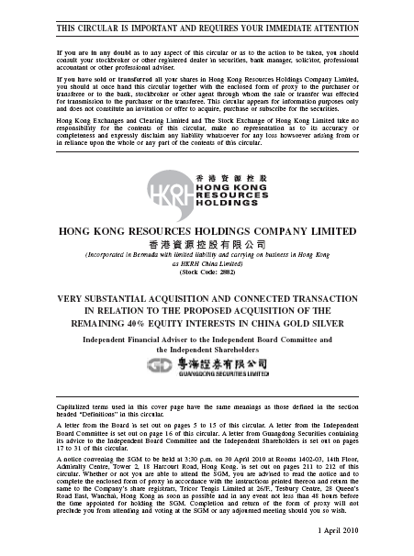

Solartech International Holdings Limited

Stock code: 1166
Circular issue date: 09-Apr-10
Mine valuation / technical report

